Project Design Phase-II
Data Flow Diagram & User Stories

Date | 29 September 2026
Team ID | 6ab3da83a238dc999eb399a3
Project Name | AI-Augmented BlogNest API
Maximum Marks | 4 Marks

Data Flow Diagrams:
A Data Flow Diagram (DFD) is a traditional visual representation of the information flows within a system. A neat and clear DFD can depict the right amount of the system requirement graphically. It shows how data enters and leaves the system, what changes the information, and where data is stored.

Example: (Simplified)
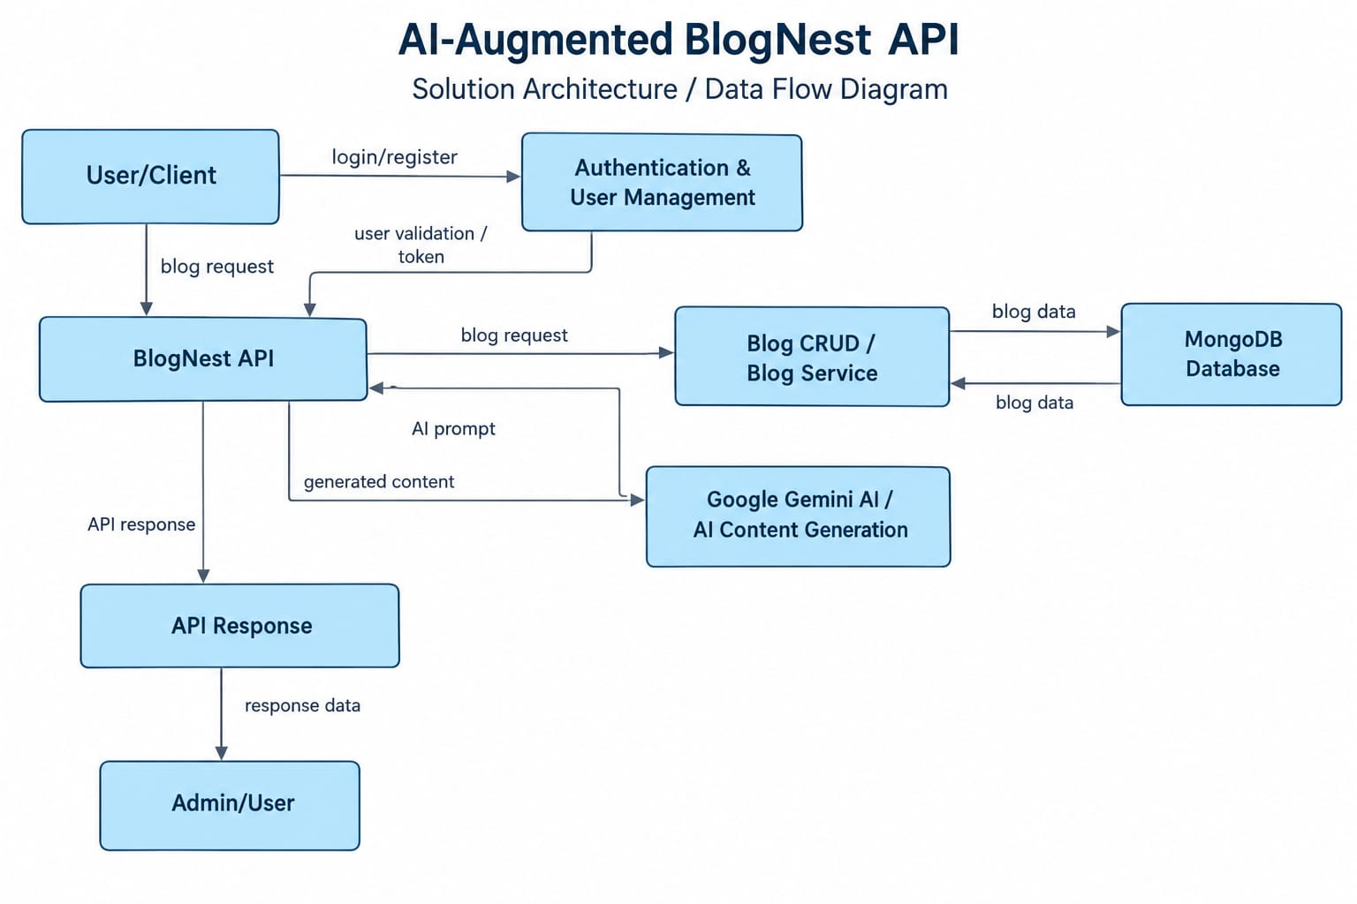
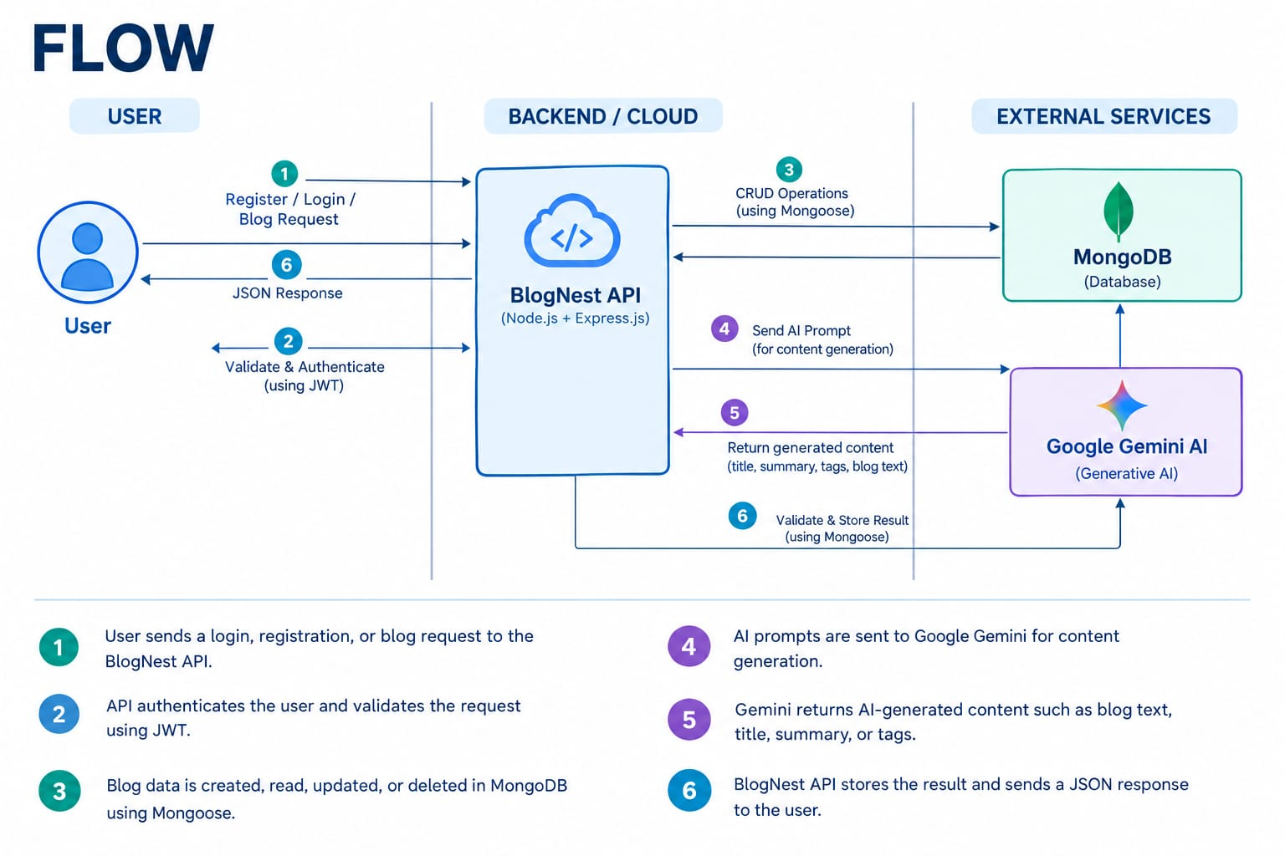

User Stories
Use the below template to list all the user stories for the product.
User Type | Functional Requirement (Epic) | User Story Number | User Story / Task | Acceptance criteria | Priority | Release
User / Blogger | Registration | USN-1 | As a user, I can register for the application using my name, email, and password. | User account should be created successfully. | High | Sprint-1
User / Blogger | Login | USN-2 | As a user, I can log into the application using my email and password. | User should be authenticated successfully. | High | Sprint-1
User / Blogger | Blog Management | USN-3 | As a user, I can create, edit, and delete my blog posts. | Blog posts should be created, updated, and deleted successfully. | High | Sprint-2
User / Blogger | AI Content Generation | USN-4 | As a user, I can generate blog content using an AI prompt or topic. | AI should generate relevant blog content. | High | Sprint-3
User / Blogger | AI Summarization | USN-5 | As a user, I can summarize blog content using AI. | AI should generate a meaningful summary. | High | Sprint-3
Administrator | API Security | USN-6 | As an administrator, I can protect API endpoints from unauthorized access. | Unauthorized requests should be rejected by the API. | High | Sprint-4

